



adges UI components library

**Component ID #1 – ex-content-rating - v1.0.0**

## Document Control

## Version History

|  |  |  |  |
| --- | --- | --- | --- |
| Version | Date | Author | Reason for Change |
| **1.0.0** | 1/17/2020 | Wael Gomaa |  |
| **1.1.0** | 23/09/2019 | Rijin Mukundan |  |
|  |  |  |  |
|  |  |  |  |
|  |  |  |  |
|  |  |  |  |
|  |  |  |  |
|  |  |  |  |

## Review History

|  |  |  |
| --- | --- | --- |
| Version | Reviewer | Date |
|  |  |  |
|  |  |  |
|  |  |  |
|  |  |  |
|  |  |  |
|  |  |  |
|  |  |  |

Table of Contents

Document Control 2

Version History 2

Review History 2

1. Document and components Purpose. 4
2. General Information. 4
3. How to use. 5
4. Component features and configure. 7
5. How to configure component. 7
6. Examples 7

# 

# Document and components Purpose.

The purpose of the document is to guide how use and configure **ex-content-rating** component.

# General Information.

Component Name: Content-rating.

Extension Theme: ex-content-rating.

Owner: Wael Gomaa.

Version no: v1.0.0

Design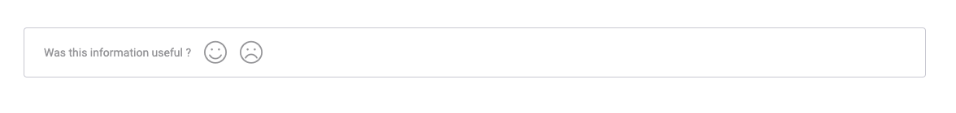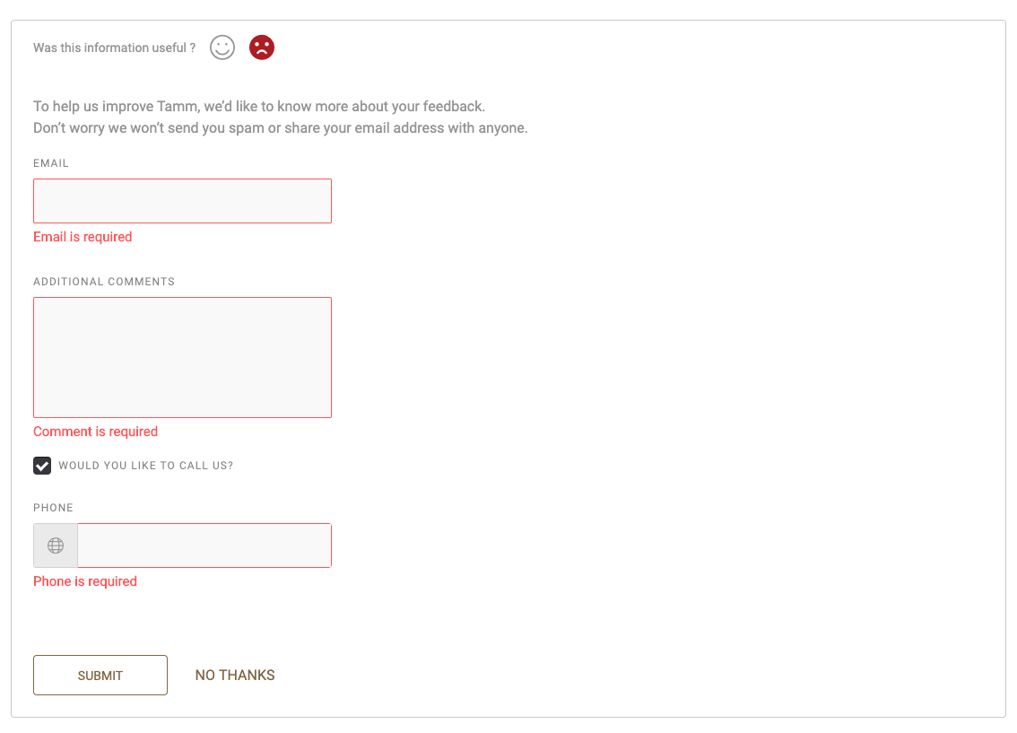

# How to use.

1. The available commands for this project .
   1. Compile : npm run gulp compile -- –path ex-content-rating –extension
   2. Compile & include under ADGE tenant : npm run gulp compile -- –path ex-content-rating –extension –full –dest [ADGEFolder]
   3. Deploy : npm run gulp deploy -- –path ex-content-rating –extension
2. *Now project have full copy from this extension theme under the project theme and you can apply the project brand guideline and configure component based on project needs.*

# Component features and configure.

You have access now to configure component with the below item.

|  |  |  |
| --- | --- | --- |
| **Feature** | **Variable** | **Default value** |
| Content rating border | $content-rating-border | 1px solid #CFCFD7 |
| **Content rating color** | $content-rating-color | #9F9FA2 |
| **Content rating font size** | $content-rating-font-size | 14px |
| **Content rating active color** | $content-rating-active-color | #AE1F23 |
| **Content rating success color** | $content-rating-success-color | #51B53F |
| **Content rating error color** | $content-rating-error-color | #AE1F23 |
| **Content rating icon font size** | $content-rating-icon-font-size | 28px |
| **Content rating title height** | $content-rating-title-height | 60px |

# How to configure component.

There are various ways to configure the component:

* **Adding Built-In or Bootstrap Class (on the variant)**
  + Spaces, Font weights, Display, Position properties etc can be added by bootstrap classes
    - Spacing: <https://getbootstrap.com/docs/4.0/utilities/spacing/>
    - Flex: <https://getbootstrap.com/docs/4.4/utilities/flex/>
    - Font: <https://getbootstrap.com/docs/4.0/content/typography/>
  + These classes should only be added to match the design
  + For built-in classes check 7 Below to see the entire list
* **SCSS Variable Override (on the _override.scss file)**
  + To configure the component we can take the above variables from section **4. Component features and configure** and add them to: adge-ph2/themes/<ADGE>/vars/_override.scss, this file with your desired changes to match the design.
* **Complete style override**
  + This should be the last and final option if the above 3 didn’t get you the desired output
  + This is overwriting the SCSS of the component by adding your own style to it
  + **Note: Take permission before doing this override**
  + Instructions:
    - Open the file /adge-ph2/themes/<ADGE>/sass/overrides.scss and add your own SCSS styles to override the faulty component.

# Dependencies

components-content-rating.css

components-sitecore-form.css

components-accordion.css

components-content-rating.js

jquery-validate-min.js

custom-dropdown.js

components-sitecore-form.js

component.sitecore.form.plugin.source.js

components-accordion.js

# Artifacts

Purpose of the content rating component to give you feedback relative to content.

# Example

-